

**Mrs. Beck’s**

**All supplies must be purchased by, August 26th**

**ART 1 SUPPLIES**

[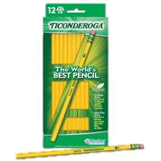](https://www.walmart.com/ip/5P1HT7EV52F7?listId=0dfdd771-9b76-4ea4-8fc7-8297972e59d1&listType=WL&listItemId=bd70b823-e4e7-48c9-a3d2-ca147b527dcc&registryId=undefined&selected=true)

[[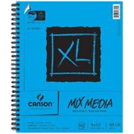](https://www.walmart.com/ip/5CDOW3QRLVIE?listId=0dfdd771-9b76-4ea4-8fc7-8297972e59d1&listType=WL&listItemId=2eca4f6f-862b-43cc-b761-8df7e5818bb0&registryId=undefined&selected=true)](https://www.walmart.com/ip/17Y6ED08YK2O?listId=0dfdd771-9b76-4ea4-8fc7-8297972e59d1&listType=WL&listItemId=944a4a64-9c4c-4daa-a5be-3f591ae21b80&registryId=undefined&selected=true)

[Canson XL Mixed Media 9" x 12" 60 Sheet Spiral Sketch Pad, 1 Each](https://www.walmart.com/ip/17Y6ED08YK2O?listId=0dfdd771-9b76-4ea4-8fc7-8297972e59d1&listType=WL&listItemId=944a4a64-9c4c-4daa-a5be-3f591ae21b80&registryId=undefined&selected=true)

[Dixon Ticonderoga #2 HB Soft Pencils, 12-Count](https://www.walmart.com/ip/17Y6ED08YK2O?listId=0dfdd771-9b76-4ea4-8fc7-8297972e59d1&listType=WL&listItemId=944a4a64-9c4c-4daa-a5be-3f591ae21b80&registryId=undefined&selected=true)

[[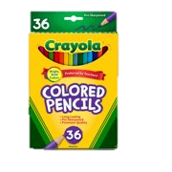](https://www.walmart.com/ip/17Y6ED08YK2O?listId=0dfdd771-9b76-4ea4-8fc7-8297972e59d1&listType=WL&listItemId=944a4a64-9c4c-4daa-a5be-3f591ae21b80&registryId=undefined&selected=true)](https://www.walmart.com/ip/6J8AOPFIE68X?listId=0dfdd771-9b76-4ea4-8fc7-8297972e59d1&listType=WL&listItemId=04d0950b-91ff-437b-bb9f-78c1969eb567&registryId=undefined&selected=true)

[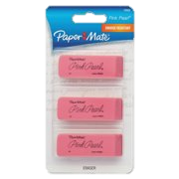](https://www.walmart.com/ip/6J8AOPFIE68X?listId=0dfdd771-9b76-4ea4-8fc7-8297972e59d1&listType=WL&listItemId=04d0950b-91ff-437b-bb9f-78c1969eb567&registryId=undefined&selected=true)

Paper Mate Pink Pearl Erasers, Medium, 3 Count

Crayola Colored Pencils, Coloring and School Supplies, 36 Count



[[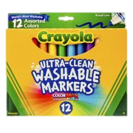](https://www.walmart.com/ip/50JRQI58ZFQK?listId=0dfdd771-9b76-4ea4-8fc7-8297972e59d1&listType=WL&listItemId=10befc33-1148-4e52-9fa8-bdf70e88e1f9&registryId=undefined&selected=true)](https://www.walmart.com/ip/6XT1SAKL0H2D?listId=0dfdd771-9b76-4ea4-8fc7-8297972e59d1&listType=WL&listItemId=787b1067-6314-47b9-8414-66818ff3d1f2&registryId=undefined&selected=true)

Crayola Washable Marker Set, 12-Colors, Broad

[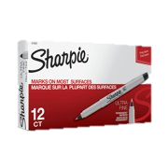](https://www.walmart.com/ip/6TMV3NSTC91G?listId=0dfdd771-9b76-4ea4-8fc7-8297972e59d1&listType=WL&listItemId=cfee4535-20e7-4c00-b8cb-d2ab9755dea3&registryId=undefined&selected=true)[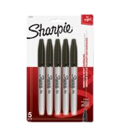](https://www.walmart.com/ip/6XT1SAKL0H2D?listId=0dfdd771-9b76-4ea4-8fc7-8297972e59d1&listType=WL&listItemId=787b1067-6314-47b9-8414-66818ff3d1f2&registryId=undefined&selected=true)

Sharpie Permanent Markers, Ultra Fine Point, Black, 12 Count

Sharpie Fine Point Marker Set of 5