Untitled:Users:kellie:Desktop:Screen shot 2013-04-05 at 3.29.45 PM.pngUntitled:Users:kellie:Desktop:Screen shot 2013-04-05 at 3.29.45 PM.pngUntitled:Users:kellie:Desktop:Screen shot 2013-04-05 at 3.20.03 PM.pngUntitled:Users:kellie:Desktop:Screen shot 2013-04-05 at 11.10.32 PM.pngUntitled:Users:kellie:Desktop:Screen shot 2013-04-05 at 11.10.32 PM.pngUntitled:Users:kellie:Desktop:Screen shot 2013-04-05 at 3.29.45 PM.pngUntitled:Users:kellie:Desktop:Screen shot 2013-04-05 at 3.20.03 PM.pngUntitled:Users:kellie:Desktop:Screen shot 2013-04-05 at 3.29.45 PM.pngUntitled:Users:kellie:Desktop:Screen shot 2013-04-05 at 3.20.03 PM.pngUntitled:Users:kellie:Desktop:Screen shot 2013-04-05 at 3.20.03 PM.png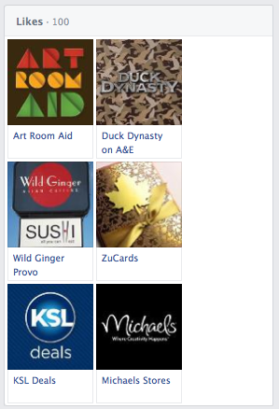Untitled:Users:kellie:Desktop:Screen shot 2013-04-05 at 3.20.03 PM.png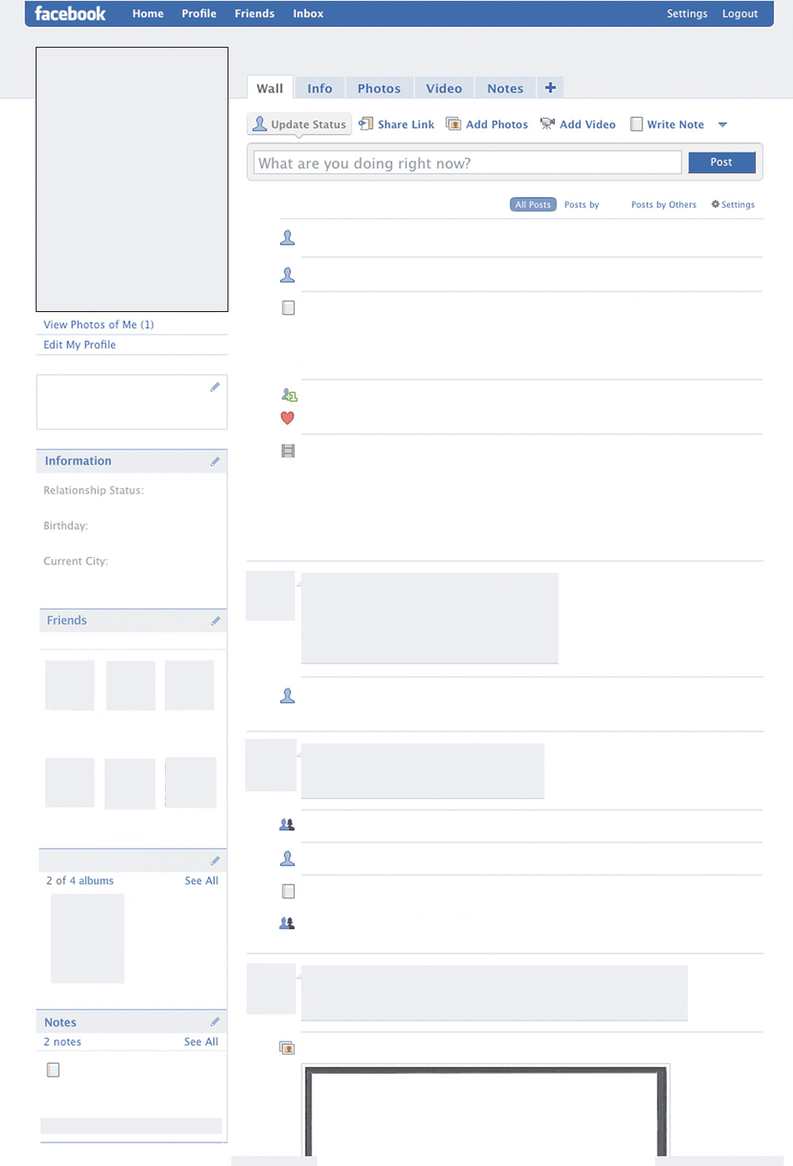

Art Style

Name

**Pic of**

**artist’s**

**like**

**Pic of**

**artist’s**

**like**

**Pic of**

**artist’s**

**like**

**Pic of**

**artist’s**

**like**

**Pic of**

**artist’s**

**like**

**Pic of**

**artist’s**

**like**

**Pic of**

**artist’s acquaintance**

**Pic of**

**artist’s acquaintance**

**Pic of**

**artist’s acquaintance**

**Pic of**

**artist’s acquaintance**

Pic of Artwork

Pic of Artwork

Pic of Artwork

Birthday, Death Day

Relationship Status

From

Lives in

Name

Name

Name

Name

Studied at

Worked at

Artist Pic Here